ChessPad V 0.1

Load, browse, modify, delete pgn files, possibly inside zip files. This is the picture of Game view:

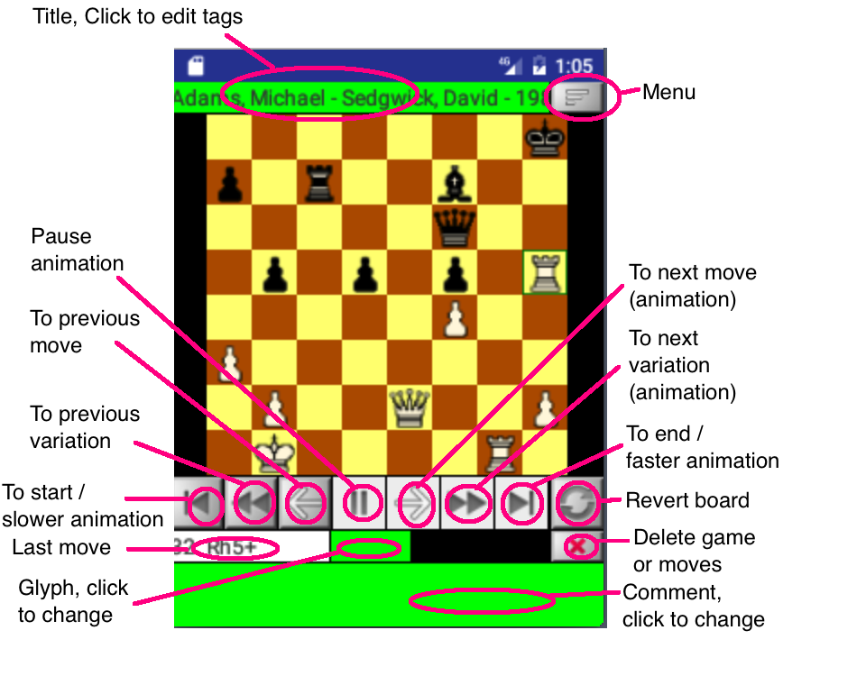

ChessPad creates a sample file ChessPad/sample.pgn so the user can get an idea of ChessPad features. Note that all modifications to this file will be lost after ChessPad is restarted.

To make a move click on the piece on the board (the square get selected like h5 on the picture) and click on the square where you want to move to. ChessPad does not allow illegal moves.

Using Menu button you can load another game, save your changes, append game to the existing pgn file or create a new pgn file containing the opened game.

When appending to a pgn file the path format is:

…/dir1/dir2/save.pgn

or

…/dir1/zipped_pgn.zip/save1.pgn

Limitation. Zip file can contain several pgn files but not directories.